ACP Middle School 2023-2024

PE Uniform T-Shirt Order Form

Sales are Thursday-Friday, **July 20th – 28th** during PE Class

All students taking PE as an elective will need to wear an approved ACP PE uniform t-shirt and solid black PE shorts. Please have your student turn in their completed order form with payment attached to their PE teacher. All order forms must be submitted with exact payment (cash or check) no later than Jan 13th.

|  |  |  |  |
| --- | --- | --- | --- |
| T-shirt Size | Quantity #  (1 or 2) | Price | Cost - $10 per piece |
| Youth Medium Shirt |  | X $10 | $ |
| Youth Large Shirt |  | X $10 | $ |
| Youth Extra-Large Shirt |  | X $10 | $ |
| Adult Small Shirt |  | X $10 | $ |
| Adult Medium Shirt |  | X $10 | $ |
| Adult Large Shirt |  | X $10 | $ |
|  |  | Amount Owed | Total $ |

Student Name: ____________________________________________________ Student ID#:_________________

Student Grade Level: ____________________________ Period # for PE: ________________________

Home/Cell Phone Number: _(________) _______________________________

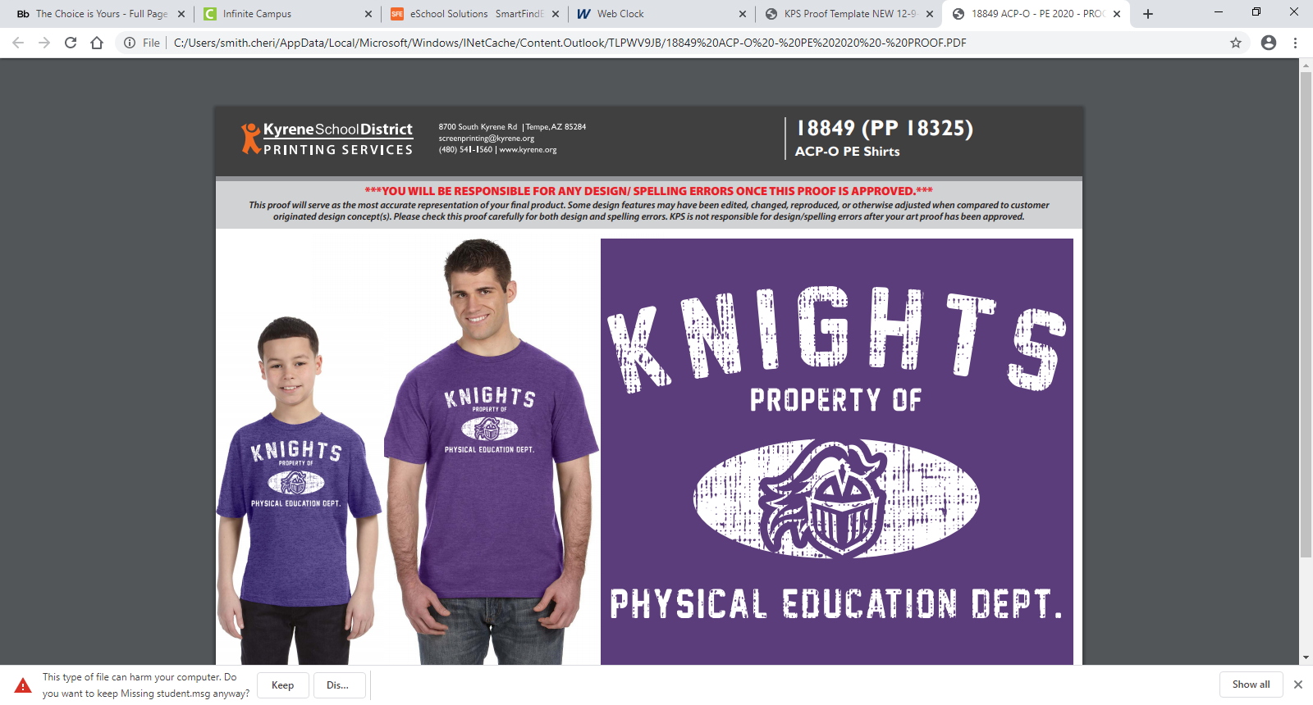Payment Method: Cash Amount $___________________ or Check Payment to ACP Oakland CK# ________________

**Please staple payment to the front of each order form and make sure your phone number and student ID# are listed on any checks. The office does not have change so please send exact cash for payment.**

**Note: Delivery of shorts may be delayed, so please pay separately (one check per form).**

Students may wear ACP PE shorts or solid BLACK Jersey PE shorts with no logo or other colors. We have only a limited number of PE uniforms available for purchase so **please limit your order to one or two shirts at this time**. Thank you!

ACP Middle School 2023-2024

PE Uniform Shorts Order Form

Sales are Thursday-Friday, **July 20th – 28th** during PE class

All students taking PE as an elective will need to wear an approved ACP PE uniform t-shirt and solid black PE shorts. Please have your student turn in their completed order form with payment attached to their PE teacher. All order forms must be submitted with exact payment (cash or check) no later than Jan 13th.

|  |  |  |  |
| --- | --- | --- | --- |
| Short Size | Quantity #  (1 or 2) | Price | Cost - $10 per piece |
| Youth Medium Shorts |  | X $10 | $ |
| Youth Large Shorts |  | X $10 | $ |
| Youth Extra-Large Shorts |  | X $10 | $ |
| Adult Small Shorts |  | X $10 | $ |
| Adult Medium Shorts |  | X $10 | $ |
| Adult Large Shorts |  | X $10 | $ |
|  |  | Amount Owed | Total $ |

Student Name: ____________________________________________________ Student ID#:_________________

Student Grade Level: ________________ Period # for PE: ________________________

Home Phone Number: _(________) _______________________________

Payment Method: Cash Amount $___________________ or Check Payment to ACP Oakland CK# ________________

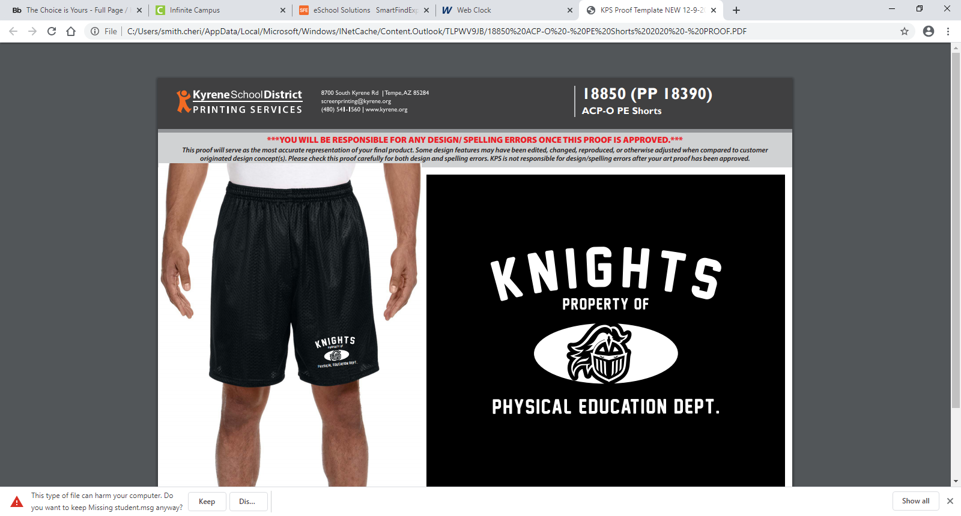**Please staple payment to the front of each order form and make sure your phone number and student ID# are listed on any checks. The office does not have change so please send exact cash for payment.**

**Note: Delivery of shorts may be delayed, so please pay separately (one check per form).**

Students may wear ACP PE shorts or solid BLACK Jersey PE shorts with no logo or other colors. We have only a limited number of PE uniforms available for purchase so **please limit your order to one or two shorts at this time**. Thank you!